Web Development – Mr. Turner

Trolls

**Project Overview**

You are given an informative HTML document about trolls. It is your job to update the document so that it is styled in a way that will be interesting to the client.

**Project Design**

All of the elements for the page are include in the HTML. Using CSS and Javascript, you will program the page to look like the screenshots and perform like the description. There is no need to change the HTML layout, however you may add ids, classes, and mouse events as necessary.

When the page loads, the user should see something that matches the following screenshot:

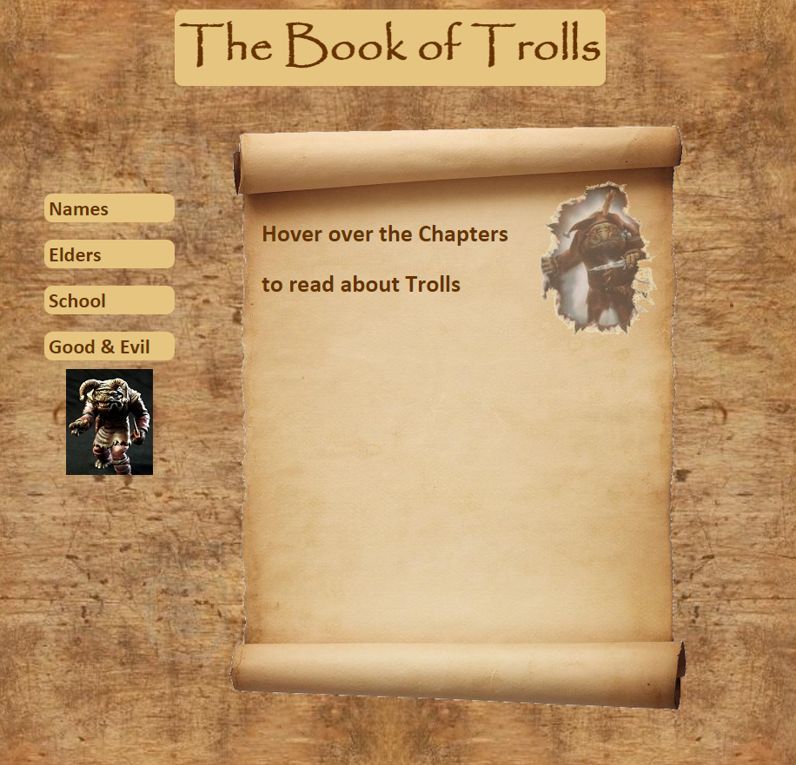

You do not have to match the fonts, colors, or even the positioning exactly. Feel free to experiment. Note, however, the following important details:

* The troll image ripping through the scroll changes size if the resolution of the page changes, but it does not change position.
* The same goes for the scroll.
* The menu on the side will also change size, but not change position. The menu has a maximum size so that it does not outgrow itself.

Whenever the user hovers the mouse pointer over one of the elements on the side list, its colors will invert and the chapter will appear in the scroll.

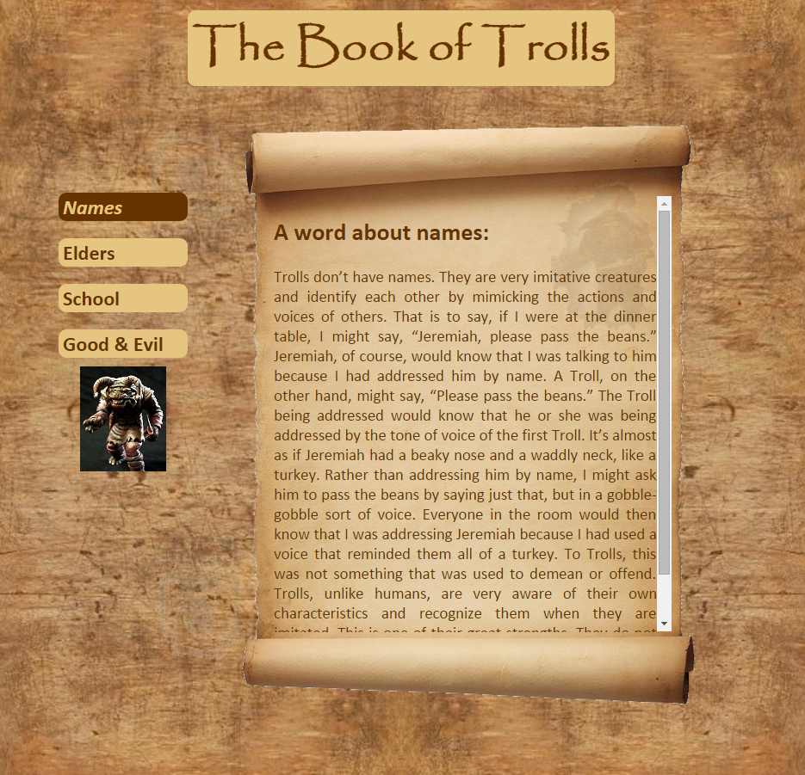 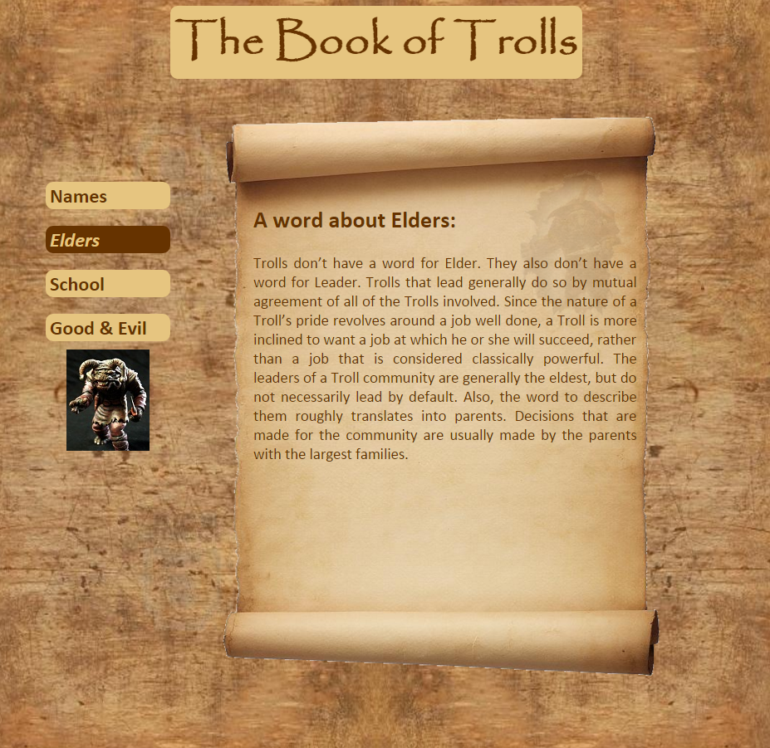

* In the screenshot on the left, a scrollbar appears because the text about names doesn’t fit on the scroll. In the screenshot on the right, there is no scrollbar. This is accomplished through CSS using the overflow property. The parent will have overflow:none while the child will have overflow:auto.
* If you click on the troll image on the side menu, it will return the page to its original state.

**Programming Requirements**

|  |
| --- |
| * You must code your own HTML, CSS, and Javascript. Use of a drag and drop interface or the usage of code downloaded from the internet is not permitted. |
| * Use of deprecated code is not permitted. Use the HTML 5 reference on [www.w3schools.com](http://www.w3schools.com) as your guide. |
| * You must comment your name into the top of every page. |
| * Your code must be structured in a consistent and legible manner |
| * Your page must be formatted using CSS. |